RESUME

Communication Address:
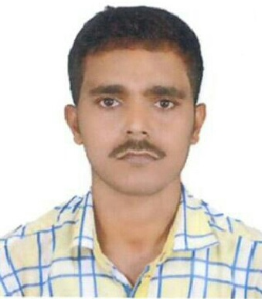
Guru Prasad Mishra
S/o- Santosh Kumar Mishra
AT/PO - Tadasramahanspur
PS-Chandanpur, Dist:- Puri
Odisha-752012
Mobile: 9937635816, 7008716250
E-Mail: gurupm95@gmail.com

.Personal Profile:

Name : GURU PRASAD MISHRA
Father's Name : SANTOSH KUMAR MISHRA
Mother's Name : LAXMI PRIYA MISHRA
Date of Birth : 07th July, 1995
Gender : Male
Marital status : Unmarried
Nationality : Indian
Language Known : Oriya, English, Hindi
Hobbies : Cricket, Reading Articles, Watching News.
Surfing Internet

Educational Qualification:

Qualification | Board | School/College | YOP | Percentage  %
Bachelor of Commerce  (Management) | UTKAL UNIVERSITY, ODISHA | P.N. (Autonomous) College, Khurda | 2015 | 66
12th  (+2 Commerce) | CHSE, ODISHA | S.C.S (Jr) College, Puri | 2012 | 59
10th | BSE, ODISHA | KATYAYASNI HIGH SCHOOL | 2010 | 67

Computer Awareness:

- POST GRADUATE DIPLOMA IN COMPUTER APPLICATION
- TALLY ERP9

STREGTHS:-
- Positive Attitude to Solve Problems
- Believe in discipline
- Always Maintain Punctuality
- Sincere Towards Profession

OBJECTIVE:-
I am seeking employment with an organization where I can use my talents and skills to help in growing and expanding the organization and also want to excel in the field with hard work and dedication

.

DECLARATION
I hereby declare that the above mentioned particulars are true to the best of my knowledge & belief.

Date: March 14, 2018
Place: PURI Guru Prasad Mishra

